INFO load :HardwareModel1921-LPP-MISPLUS4.txt

Example Ticket – **270910190**

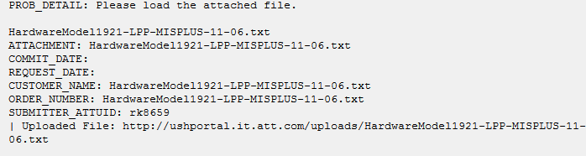

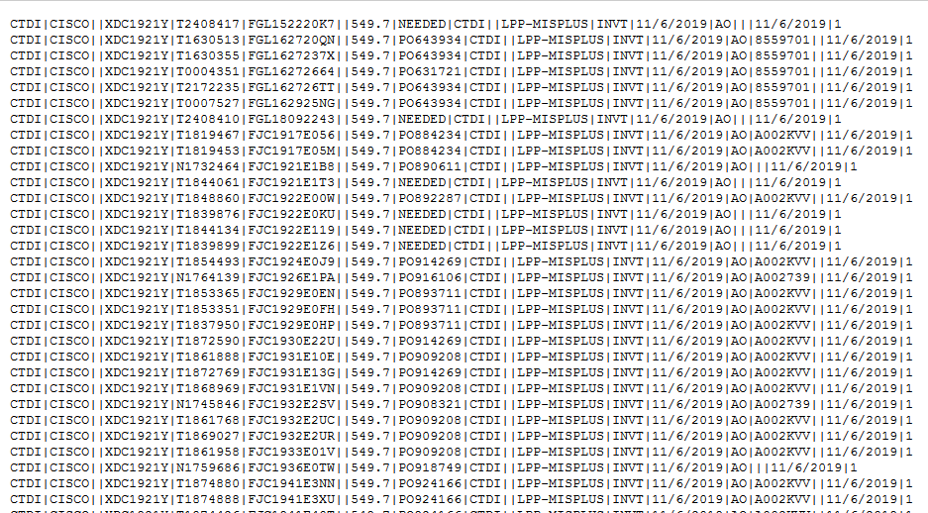

1. **Log into lpp0fe 01 Server**

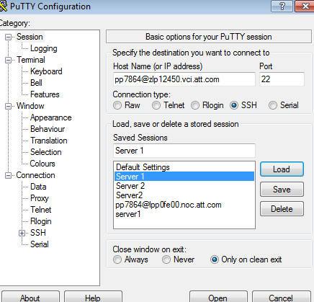

**2)Go to NC3** by using sudo su - nc3



After that do the following steps to load the information:

3)cd /opt/nc3/current/data/infoload

**4)create file :-**  vi Infofile_06_10_2019

**5) Insert the data**

esc i

paste the data in file

esc:wq (save the data)

**6)Run the file created:-**

/opt/nc3/current/etc/run/misc/INFOLoad.sh Infofile_06_10_2019 HmodelPartFile ManufacturerFile warehousefile error_file_06_10_2019

**7) check for errors by using below command:**

cat error_file_06_10_2019

**8)Update the Logs :**

We have processed the Info Load File in this ticket as requested. Please check and let us know if the data appears to have processed correctly.

Infoload purpose is to load information related to routers,serial numbers, asset tags

Also, fill the below details while closing the ticket

